

Applied Dev.Ops

Task 3 Report



September 23, 2023

**Tayyab Shahid**

**19F-0911**

# **GitLAB:**

* I choose GitLAB tool for Applied DevOps
* Created Account on GitLAB

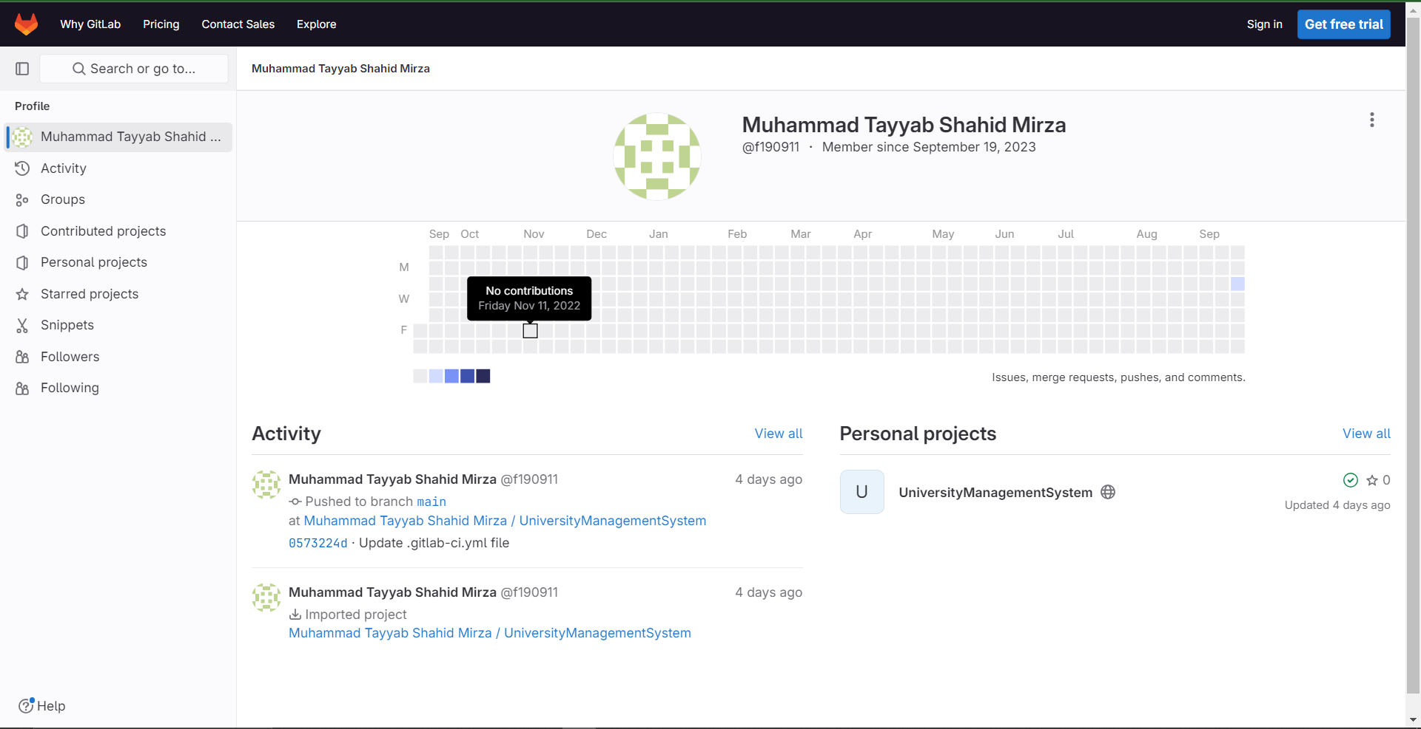

* Cloned my project from GitHub Repository

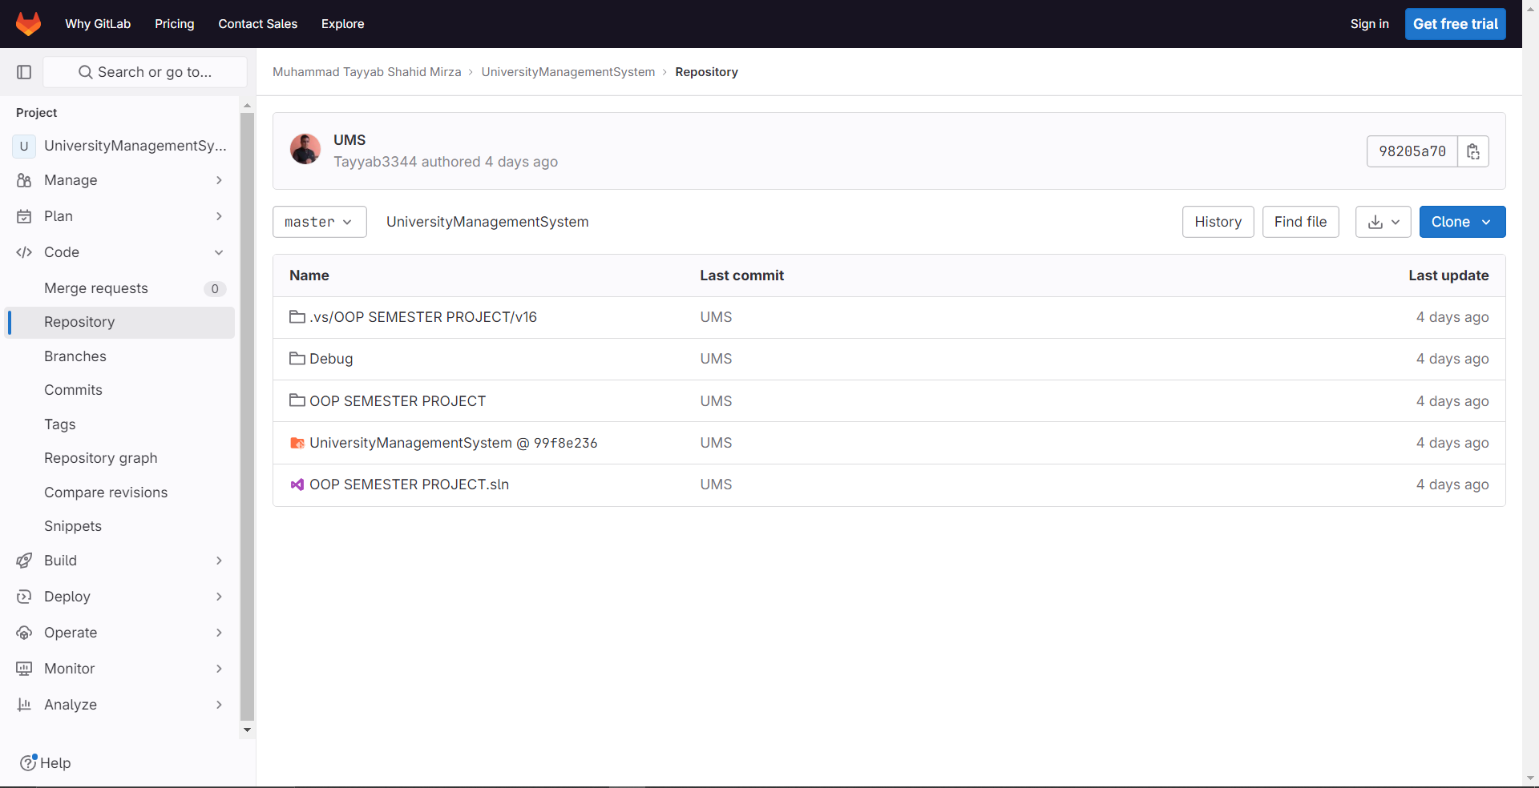

* Created Pipelines of Cloned Project

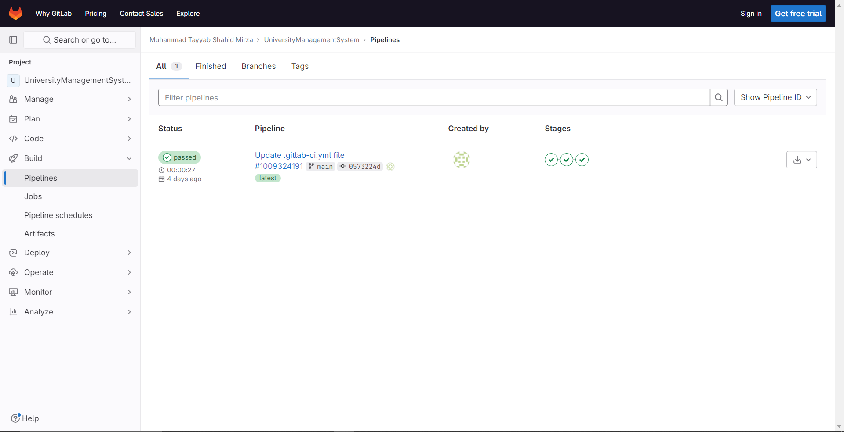

* Pipeline Passes Details

